QQC 3
The Book: Drive- The surprising truth about what motivates us
Author :Daniel Pink

While reading the book, I kept on looking for an answer to what motivates people to do what they do? In the quest to find an answer to the question, I reflected on what I do and why I do certain tasks. I also talked with my students, my mother and my colleagues. While I was talking with them, I was constantly going back and forth to understand various researches done to find the surprising truth about what motivates people.
My conversations:
Scenario 1
I walk into the class and see students playing computer games. Everyone is so engrossed that they don’t realize I have entered the room. I observe them for a while..I see excitement on their face involvement in the game..Sitting there for a while..I wonder…what is the magic of motivation in these computer games which keeps these students so engrossed?
The next day in my advisory class, I asked the students about their involvement in the computer games every day. They said, it is challenging and it is fun. It refreshes our mind. There is a sense of achievement. So aren’t Math problems challenging? I asked. They said, ‘yes they challenge us, but it’s not fun”. This opened up to a very interesting conversation. We discussed about their passion in sports, photography, robotics, movie making etc. This led to a good discussion in the class with everyone sharing their passion.
Scenario 2
I go home and I see my mother busy for nearly an hour or two - what is she busy with…playing her favorite game on the mobile..Someone who cannot sit for 30 min in any social function can sit for 3-4 hr playing games…I wonder-what’s the magic?
I asked my mother the same question…she said, it is fun. It is fulfilling to win a game even when I am playing alone..
Both this conversations kept me wondering for few days… What is working for them? And I connected with these lines..
‘That enjoyment-based intrinsic motivation, namely how creative a person feels when working on the project is the strongest and most pervasive driver”..pg 23
What drives participants is “a set of predominantly intrinsic motives”- in particular, “the fun…of mastering the challenge of a given (software) problem”..pg 23
Then I asked my students - What if I start paying you for every game you win or the best photograph you click or every football match you win? I thought they will all be excited to earn few bucks and accept the challenge. But to my utter surprise, they unanimously said, ‘No Ma’am, that will lose our interest and the excitement. We will not be able to give our best as we will have to live up to the expectation of the reward and we will have to meet a specific deadline’
“if then” rewards require people to forfeit some of their autonomy…..And that can spring a hole in the bottom of their motivation bucket, draining an activity of its enjoyment..pg 38
Then I asked the most common question to them “Why do they work hard for the examination? If the reward is not so important for them, why do they strive to score maximum marks- aiming to be toppers in class? They said, we work hard so that our parents feel happy. We are good students’ in our teachers’ eyes. This was a big surprise for me. Do students come to school because they are forced to come? Do they study to please their parents and teachers?
But goals imposed by others…can sometimes have dangerous side effects pg. 50
It took a while for me to realize, the core to motivation is internal to the individual involved. Work enjoyment and performance are closely linked. If people really enjoy what they do, they are likely to do it well. Again, the need to understand what creates enjoyment in the people most qualified and apt to maximize performance on and individual and team basis. What works for one may have the opposite effect on another and it is a teacher’s job to understand her students individually and as a group and provide the "motivational components" necessary to maximize performance for each student and the whole class at the same time. For some to maximize performance autonomy is good / required. For others autonomy may be counterproductive, with more guidance needed to provide the most effective performance. Autonomy is earned as a result of purpose and mastery.

Scenario 3
While reading chapter 3 Type I and Type X (pg 70), the following lines helped me reflect deeply.
Think about yourself. What energizes you-what gets you up in the morning and propels you through the day-come from inside or outside? How about men and women around you work? Pg 78
My reflection helped me to instantly sense into which category I belonged to. It was Type I. But I was not sure, so I took the test recommended on the last page. Are you type I or Type X?
I was surprised by the test result !! It read -You are Type X
And I said how this is possible? I was so sure that I fit into these lines “For Type I’s, the main motivator is the freedom, challenge, and the purpose of the undertaking itself; any other gains are welcome, but mainly a bonus” pg 78
I thought of sharing it with few of my collegues
I sent the survey link to 10 of my colleagues who I thought fit into the Type I category. 6 out of 10 sent me the result. All of them wrote ‘TYPE X’. All of them had saw themselves in Type I category, but the result surprised them as well…
I took the opportunity to discuss ‘Drive’ with few of my colleagues who gave me a great insight and enhanced my understanding on motivation.

My conclusion
Motivation is a driving force. It’s a carrot on a stick, an incentive, an attraction, an urge, a triumphant call. Motivation is a siren song, a persuasive spirit, a compulsion, an obsession. Your ability to get things done is determined by your level of personal motivation. Reminding yourself of what you want is a powerful motivator to help you get what you want.
Posters that motivate me….

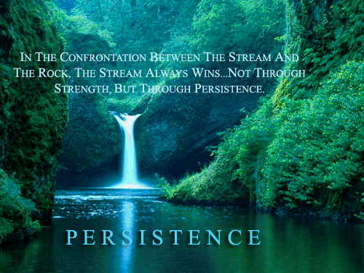

My burning questions:
- To what extent autonomy works with students?
- With so many attractive alternatives competing for students' attention, motivating them to focus and perform is increasingly becoming a difficult task… How do teachers continue to motivate students who have different interests?

