QQC-4
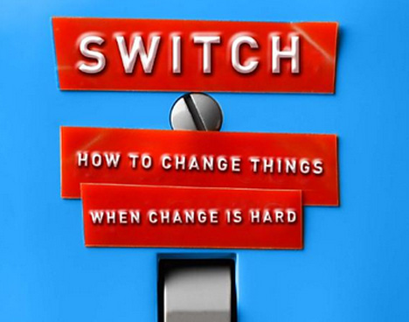

Book-“Switch: How to Change Things When Change Is Hard"
Authors- Chip Heath and Dan Heath
===================================================================

We all know change is hard. It’s unsetting, it’s time-consuming, and all too often we give up at the first sign of a setback (Back cover).
Anyone who has ever been on a diet, or is part of our school- The Galaxy Education System (TGES) , or even dealt with students in any school knows how difficult change can be. Whether it’s finding the will to not open a bag of chips or trying to stop oneself from getting into the same old argument with a colleague, we all know old habits die hard. When change is hard, when it feels improbable or even impossible, the overwhelming desire to throw up our hands and call it a day is difficult to fight. But, as explained in the book ‘SWITCH’, what seems impossible may just be a problem of clarity, motivation, or environment. When change is needed, there is a way to make it happen.

The sciences of human behavior can provide us with tools for making changes in our lives—tools that are more effective than "willpower," "leadership" and other easier said than done solutions. The book explains a couple of fundamental principles of psychology and gathers from them concise recommendations for bringing about change. The book conveys the ideas primarily through stories about people, companies and organizations that have successfully undertaken major changes, sometimes in the face of long odds

The first psychological principle that "Switch" exploits is the fact that our brains do not contain a single, general-purpose decision-making unit. Instead, we have two systems: one that is rational, analytical and slow to act; and another that is emotional, impulsive and prone to form and follow habits. In "Switch" these systems are the "Rider" and the "Elephant," respectively.

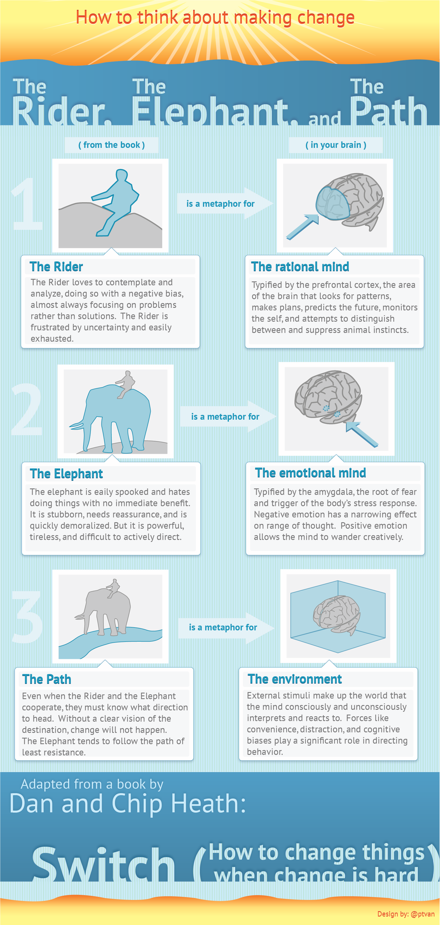

"Switch" doesn't announce any scientific breakthroughs. Politicians, for instance, have long known that appealing to emotion is more effective than appealing to logic—not because people are stupid but because the mind is designed to use logic as a tool for supporting our beliefs rather than for changing them. It took some pretty big emotional events, not new facts or arguments, to make me get serious about losing weight. What the book does well is to explain how important it is to bring both systems onboard for change—and explain why that still isn't enough.

I managed to lose about 9 kilos (20 pounds) over the course of six months. When colleagues ask how I did it, my immediate answer is that I hardly exercise, but I do try hard to follow the rules of food intake to an extent that will gradually cause me to lose weight. I followed a diet plan.
But it wasn't really that simple. Millions of people are trying to lose weight all the time, and millions of others who do lose several kilos find that the loss is temporary. For some mysterious reason, I have succeeded (so far, at least). Reading the book “Switch: How to Change Things When Change Is Hard" helped me understand why.

When I started the diet plan to lose weight, it wasn't enough to have an abstract goal of "being healthier" or even "losing few kilos." As the Rider needs a series of rules to follow, precise actions that will each achieve a minor goal and move one step closer to a major one. Each day that I ate the right number of calories was a small victory, and I couldn't have had such victories without knowing what the "right" number was in the first place.
The Elephant needs motivation to change—an emotional rationale. Not long before I decided to lose weight, I had been to the orthopedic doctor to find a cure for my severely aching knees, where I discovered that the cause was a combination of my increasing weight and reverse arthritis where my own protective cells were damaging the others. The doctor explained in very simple language. He said, ‘your army is killing your own soldiers’, if you do not take care of it now, you will not be able to walk in few years. And I found my values shifting. I could not imagine myself unable to walk. I decided to follow his medication and also met the nutritionist who guided me meticulously on what to eat and what not. What unified the needs of the two systems is concrete information, like the specific number of daily calories and the mental image of myself unable to walk in few years if I did not take care. Abstract ideas and concrete information are processed differently by the brain, and concrete information has more motivating force.

The other major psychological principle at work in "Switch" is the idea that, more than we suspect, outside influences control our actions. All the good intentions and native intelligence in the world can be defeated if the setting is not right. But small changes to one's environment can have a big effect. For any effort at change to succeed, the Heaths argue, you have to "shape the path”.

The book, summarizes that in order to create change, you must do three things: (Page 259)
- Direct the Rider (Reach the rational side)
  - Follow the Bright Spots: Investigate what’s working and clone it.
  - Script the Critical Moves: Don’t think big picture, think in terms of specific behaviors.
  - Point to the Destination: Change is easier when you know where you’re going and why it’s worth it.
- Motivate the Elephant (Reach the emotional side)
  - Find the Feeling: Knowing something isn’t enough to cause change. Make people feel something.
  - Shrink the Change: Break down the change until it no longer spooks the Elephant.
  - Grow your People: Cultivate a sense of identity and instill the growth mindset.
- Shape the Path
  - Tweak the Environment: When the situation changes, the behavior changes. So change the situation.
  - Build Habits: When behavior is habitual, it’s ‘free’ — it doesn’t tax the Rider. Look for ways to encourage habits.
  - Rally the Herd: Behavior is contagious. Help it spread.

Sometimes it may be that the push to change only requires a few of these suggestions. Other times, however, it may require all of them. The case studies cited throughout Switch, demonstrate that each situation is unique. But once you figure out the issue that is stopping the change, using one of these techniques provides a clear-cut way to sort out the confusion that usually surrounds any transformation.
Whatever the case, after reading this book, I knew that in order to make my diet better, I would need more direction, more motivation, and an easier path. No matter how much I understood that I needed to eat healthier, my sweet tooth frustrated me time and time again. So I directed my rider ( no sweets, and no carbs after 7 pm), motivated my elephant (put pictures of my skinnier self from a couple of years ago on my cupboard door where I’d have to look at them daily), and shaped my path (packed my lunch with no sweets and got rid of all the sweetened drinks and chocolates in my home).

As I reflect after reading this book I conclude that there were many such elements in my work which were more from experience or from trial and error without any specific strategy. It was situational and most of it emerged from experience or need of the hour. I realized that ‘Switch’ has helped me reflect and understand the science, the cognitive understanding behind these situations. I now reflect upon some of my conversations with students and can feel that if I had ‘motivated the elephant’; it could have helped me deal with situations meaningfully. Now the jigsaw of communications seems less puzzling.

